Raspberry Pi Pico W with IMU-BNO055

- Connect Raspberry Pi Pico W with IMU- BNO055.

Raspberry Pi Pico W | IMU- BNO055
GP0 | SDA
GP1 | SCL
GND | GND
3V3 | 3V

Refer below pics for connections
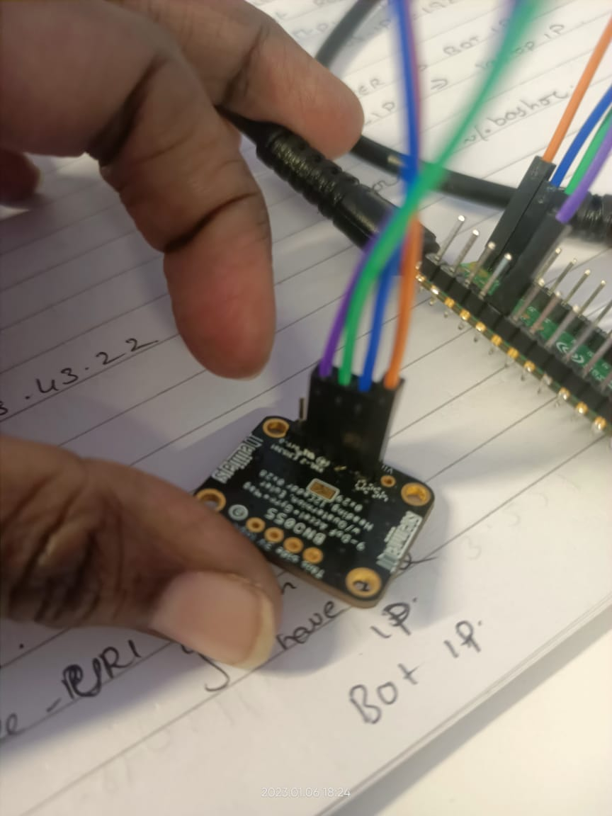
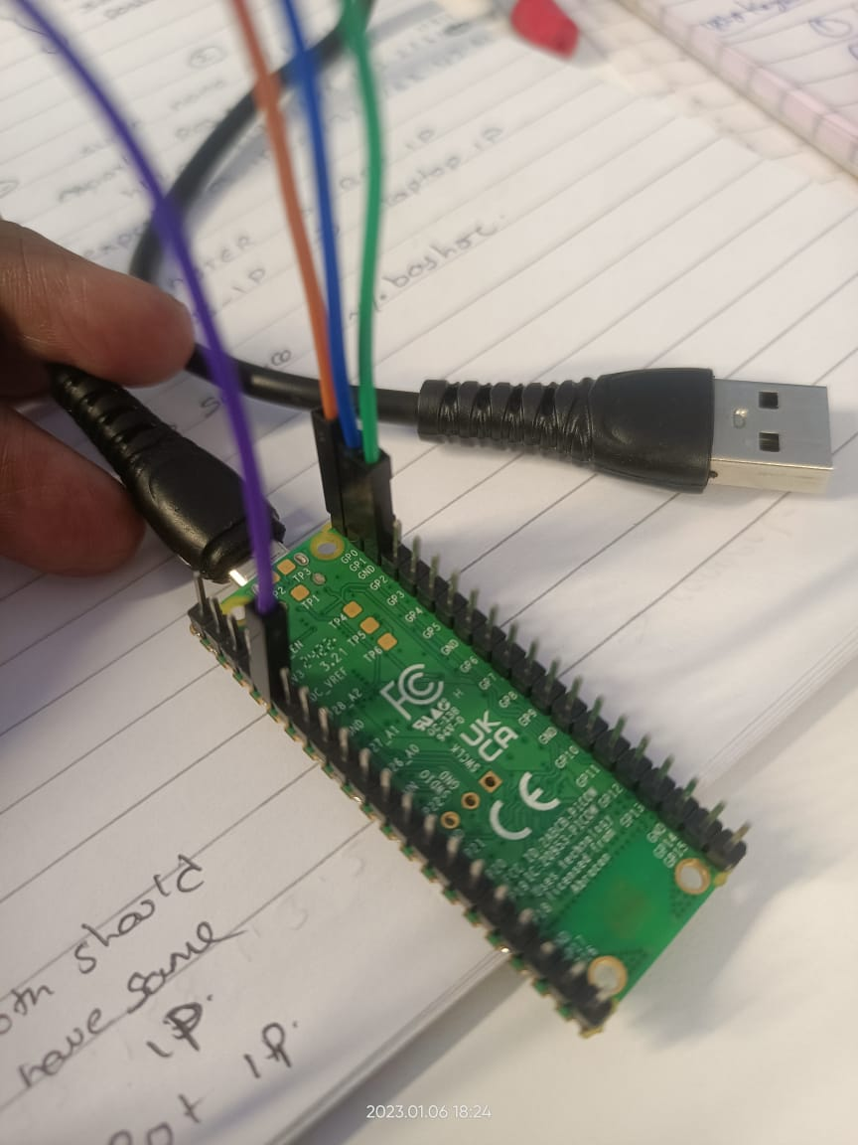
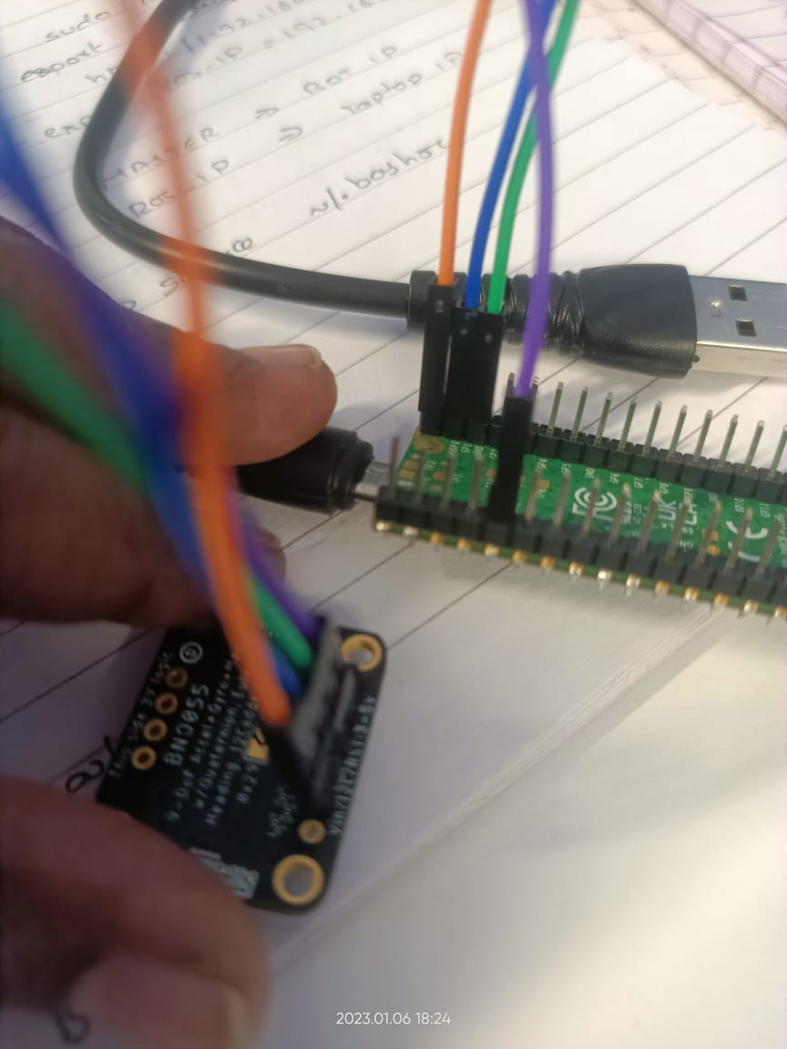

- Connect Raspberry Pi Pico W & IMU-BNO055 with laptop using Btype cable.
- Open RPI (Connected device) from your laptop.
- Select Index it will redirect to webpage.
- Download Micro python on Raspberry Pi Pico W (connected device)
- Install Thonny IDE in your laptop
  - https://thonny.org/
  - you can open Thonny IDE through your terminal or through applications.
  - Select Tools→Options →Interpreter →select Micropython Raspberry Pi Pico from dropdown & select the port which you are working.
  - If you get any Port error, give permission to the port which you are working from terminal (‘sudo chmod 777 /dev/ttyACM0’)
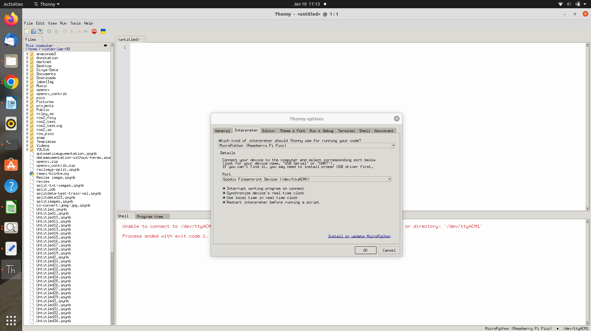

  - In Thonny write code to get data from IMU-BNO055.

    - import machine
    - import time
    - import bno055
    - from bno055 import *
    - # Pyboard hardware I2C
    - i2c = machine.I2C(1)
    - # ESP32 and ESP8266 soft I2C
    - i2c = machine.SoftI2C(scl=machine.Pin(1), sda=machine.Pin(0), timeout=100_000)
    - imu = BNO055(i2c)
    - calibrated = False
    - while True:
    - time.sleep(1)
    - if not calibrated:
    - calibrated = imu.calibrated()
    - print('Calibration required: sys {} gyro {} accel {} mag {}'.format(*imu.cal_status()))
    - print('Temperature {}°C'.format(imu.temperature()))
    - print('Mag x {:5.0f} y {:5.0f} z {:5.0f}'.format(*imu.mag()))
    - print('Gyro x {:5.0f} y {:5.0f} z {:5.0f}'.format(*imu.gyro()))
    - print('Accel x {:5.1f} y {:5.1f} z {:5.1f}'.format(*imu.accel()))
    - print('Lin acc. x {:5.1f} y {:5.1f} z {:5.1f}'.format(*imu.lin_acc()))
    - print('Gravity x {:5.1f} y {:5.1f} z {:5.1f}'.format(*imu.gravity()))
    - print('Heading {:4.0f} roll {:4.0f} pitch {:4.0f}'.format(*imu.euler()))

  - Run the code and resolve if u get any errors.
  - Below will be output.
  - Save it in Micropython.

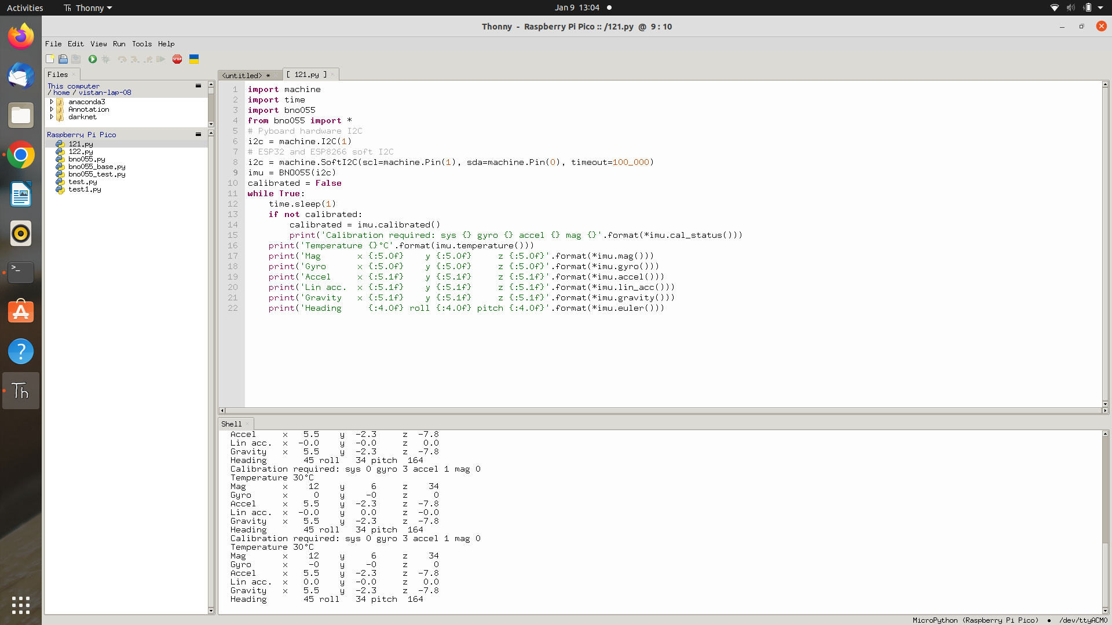

  - Move IMU-BNO055 and you will notice that the values are changing accordingly
  - These are the outputs we will need.

Reference Links:-

For Thonny Installations:- https://www.youtube.com/watch?v=a7BUz0wA5ek
BNO055 Installations:-
https://github.com/flynneva/bno055
https://www.youtube.com/watch?v=pKt3-PK-Ing

